Low Voltage Fuses

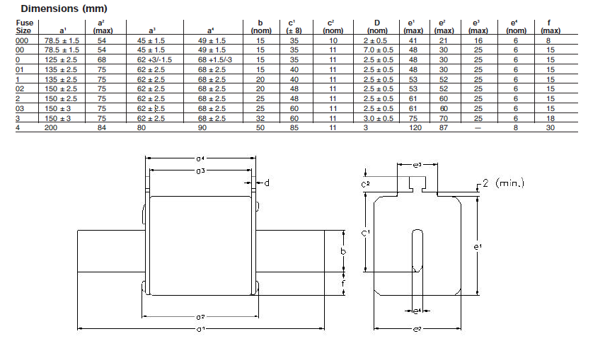
High efficiency low voltage fuses high breaking capacity to produce rated voltage 500VAC in sizes:

- NH-00 (for the body 160A) - 6 - 160 A
- NH-0 (160A to stand) - 6 - 160 A
- NH-1 (250A to the base) - 40 - 250 A
- NH-2 (for stand 400A) - 40 - 400 A
Fuses correspond to standards: IEC 60269-1, IEC 60269-2 - Type A.ISO standard
Fusible inserts are gG (gL) characteristics and are designed for reliable and economical insurance for electrical, cable and overhead lines, machines and devices from overload current and short circuits.
Ceramic housing provides high temperatures, mechanical and electrical reliability. It is made of ceramic material proposed for making the fuse IEC60672-1.
Contact blades are made of Cu alloy with appropriate surface protection.
Socket fuse of the steel surface protected by galvanization.

Pos. 1. 17.1.40 Fuse Type NH3, 500V; 120kA; 250A

No. | Description | Unit | Requirement | Supplier’s Offer
1 | Manufacturer
2 | Country of origin
3 | International standard
4 | Frequency | Hz | 50
5 | Rated Voltage Un | V | 500
6 | Breaking capacity | kA | 120
7 | Melting characteristic |  | gL / gG
8 | Insulation voltage | V | 1000
9 | Rated operational voltage Ue |  | 400V AC;  500V AC;  660V (690)V AC;
10 | Dimension a¹ | mm | 150 (±3)
11 | Dimension e² (max) | mm | 70
12 | Warranty

Pos. 2. 17.1.37 Fuse Type NH2, 500V; 120kA; 250A
No. | Description | Unit | Requirement | Supplier’s Offer
1 | Manufacturer
2 | Country of origin
3 | International standard
4 | Frequency | Hz | 50
5 | Rated Voltage Un | V | 500
6 | Breaking capacity | kA | 120
7 | Melting characteristic |  | gL / gG
8 | Insulation voltage | V | 1000
9 | Rated operational voltage Ue |  | 400V AC;  500V AC;  660V (690)V AC;
10 | Dimension a¹ | mm | 150 (±2.5)
11 | Dimension e² (max) | mm | 52
12 | Warranty

Pos. 3. 17.1.35 Fuse Type NH2, 500V; 120kA; 160A
No. | Description | Unit | Requirement | Supplier’s Offer
1 | Manufacturer
2 | Country of origin
3 | International standard
4 | Frequency | Hz | 50
5 | Rated Voltage Un | V | 500
6 | Breaking capacity | kA | 120
7 | Melting characteristic |  | gL / gG
8 | Insulation voltage | V | 1000
9 | Rated operational voltage Ue |  | 400V AC;  500V AC;  660V (690)V AC;
10 | Dimension a¹ | mm | 150 (±2.5)
11 | Dimension e² (max) | mm | 52
12 | Warranty

